Electrical Signals 2 Assignment

Synaptic Transmission and Propagation of APs

Go here:
http://www.blackwellpublishing.com/matthews/animate.html
If it doesn’t open, go to: http://www.blackwellpublishing.com/

Then add the following to the address:
http://www.blackwellpublishing.com/matthews
Then click on “Animations” on the left side of the page.

Watch the Channel Gating animation.

Watch the Propagation of the Action Potential animation. Watch both animations. Compare continuous conduction in the unmyelinated fiber to saltatory conduction in the myelinated neuron.

Watch the Synaptic Vesicle Fusion and Neurotransmitter Release animation.

1. Make a flow chart that shows the events that occur at a synapse when an AP
reaches the axon terminal.

2. Compare propagation of APs in myelinated and unmyelinated axons.

Comparison of Endocrine System and Nervous System

 | Endocrine System | Nervous System
Types of Signals
(Chemical or Electrical or Both)
Speed of Transmission
(Fast or Slow)
Duration of Response
(Short or Long)

Comparative Animal Nervous Systems

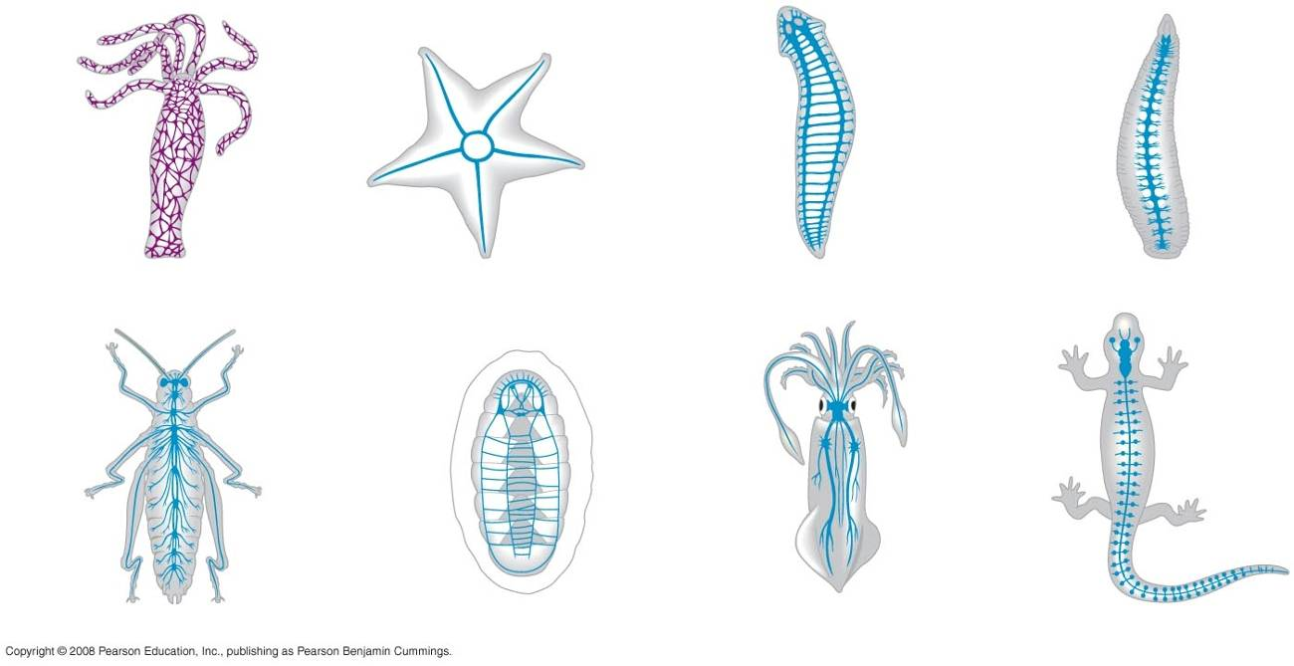

3. Compare the nervous system of cnidarians, flatworms, annelids, arthropods, and vertebrates.

4. What is the difference between a centralized nervous system and the central
nervous system (CNS)?

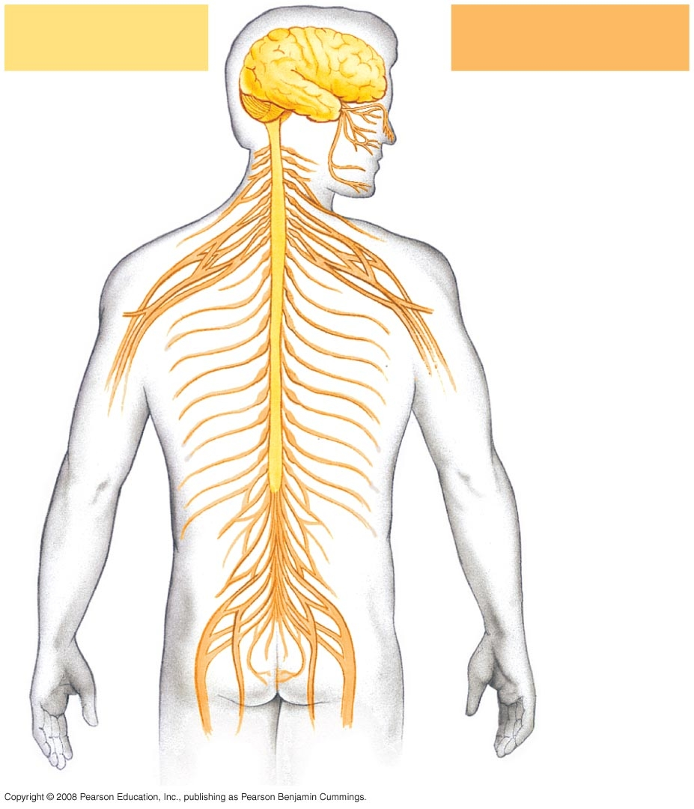

5. On the diagram above, what part of the nervous system is indicated in yellow?

6. What part is indicated in orange?

7. Name the two parts of the central nervous system.
Relationship Between Brain Folding and Complexity

8 What is the effect of folding on the surface area of the cerebrum and cerebellum?

9. What is the effect of folding on the number of neurons that can be packed into a
brain part?

10. What is the effect on the ability of the animal to process information and have
complex behaviors?

11. Using the diagrams below, which animal would you predict to have the most
complex brain, including more complicated neural pathways and greater
processing power?
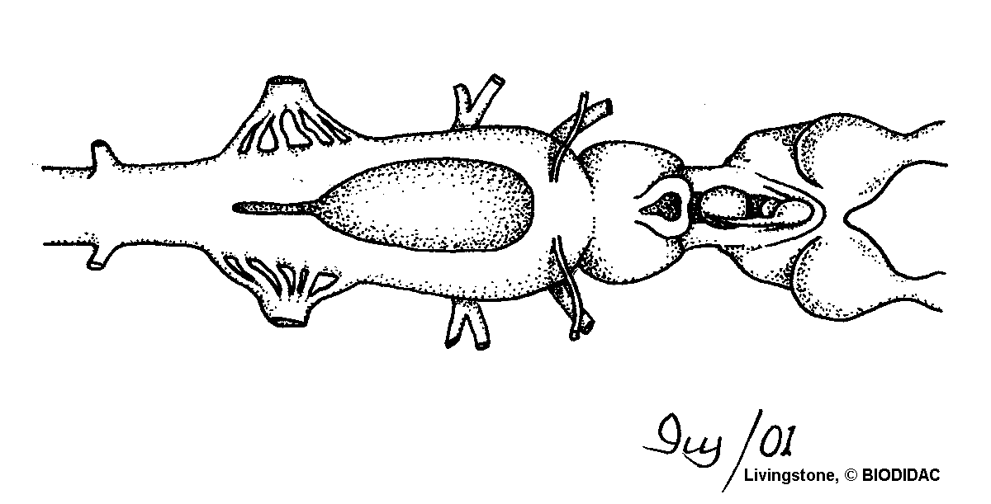
anterior
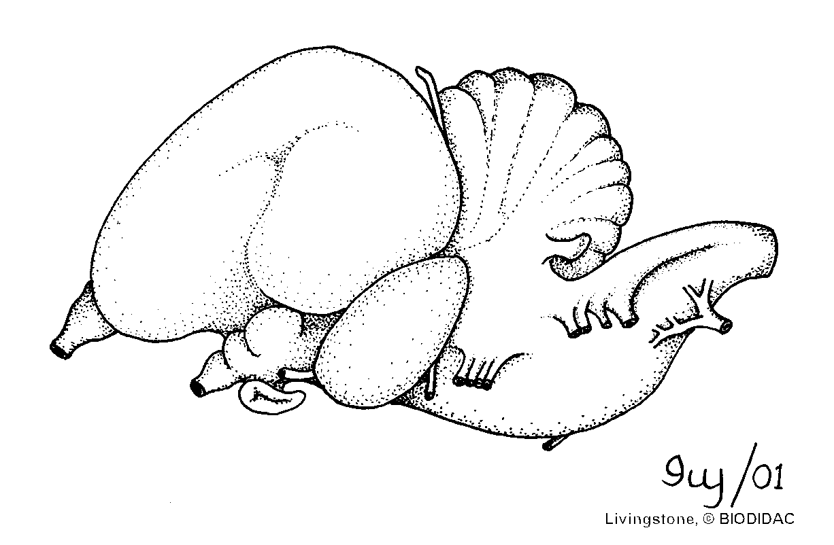
anterior
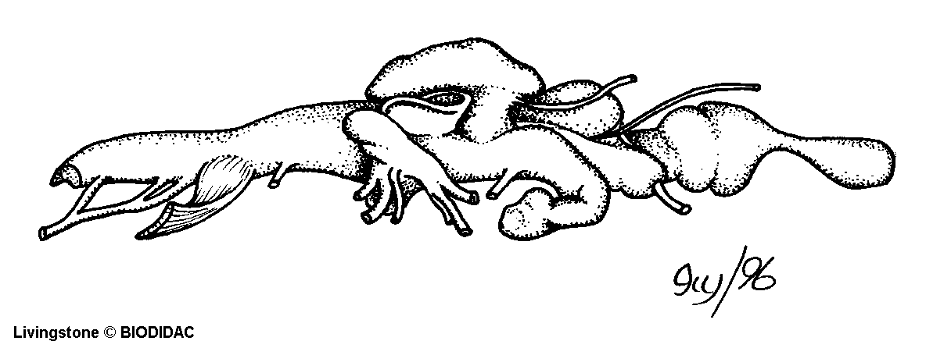
anterior

Cerebrum, Cerebellum and Brain Stem

12. Label the colored region below with the part of the brain:
● Brain stem
● Cerebellum
● Cerebrum.

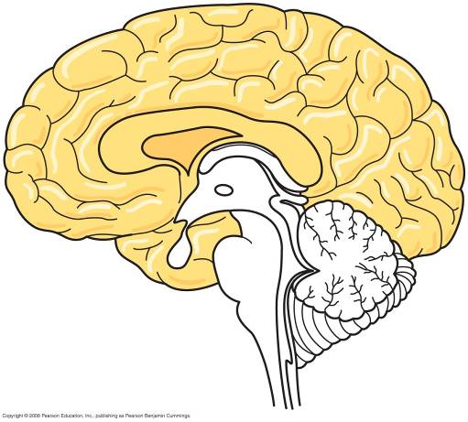

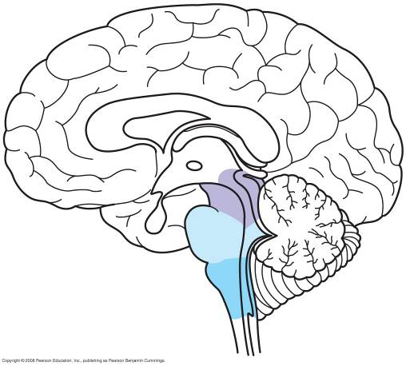

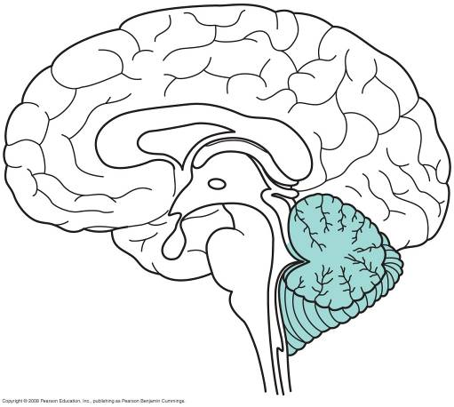

13. In vertebrates, the cerebrum carries out higher level processing, such as memory,
learning, problem-solving and other tasks. Coordination of motor skills is the
primary role of the cerebellum. The brain stem carries out basic housekeeping
functions, such as heart rate, breathing, blood pressure, etc.

Given this information, predict which area of the brain you would expect to be
larger in the following situations.

a. Flight is the most demanding form of locomotion. In addition to power yourself
up against gravity, you have to maneuver through a complex three-dimensional
environment. Due to the demanding motor skills required to fly, you would
expect this part of the brain to be very large in birds.

b. Snow leopards live in the Himalayas in very harsh conditions. Most cubs stay
with their mothers for at least two years before they are capable of hunting for
themselves. During this time, they learn how to ambush their prey from
watching their moms. Due to the complex behavior and the amount of time that
it takes to train offspring how to hunt successfully, you would expect this part of
the brain to be very large in snow leopards.

c. Experiments with frogs have shown that frogs are able to swim and hop after
the cerebrum has been removed. Later experiments have shown that most
behavior in frogs are due to reflexes. Frog brains do not have large capacity for
learning. Which of the three parts of the brain mentioned above would you
expect to be largest in frogs?

